Nudged Elastic Band Tutorial
A simple walkthrough and template for NEB runs on VASP.

https://github.com/drinwater/Nudged-Elastic-Band-Tutorial

The Basics

NEB is used to determine the transition state and energy barrier of a reaction pathway. An initial (IS) and final (FS) state is used as the beginning and final images. A number of user chosen "images" is then used for the pathway. An interpolation between the points is performed to give a good initial guess, and run a standard VASP run in the same directory as all our NEB files albeit with a few modifications to the INCAR input file.

An NEB band of for example, an N₂O bond dissociation on a Pd (111) surface scenario, might look Figure 1(a). The issue here is there is no one specific image that seems to correspond to the transition state, because a TS would be a saddle point (highest point). To overcome this, the Climbing Image-NEB method is used. Using the Cl-NEB method, a single image is allowed to "climb" so that a saddle point is obtained. A successful CI-NEB run would generate an NEB band as shown in Figure 1(b). In this case, there appear to be two saddle points. To confirm which one is the TS, we conduct vibrational frequency calculations at the two images. A TS has exactly one imaginary frequency, so that would be an indicator of which of the two saddle points is the real TS.

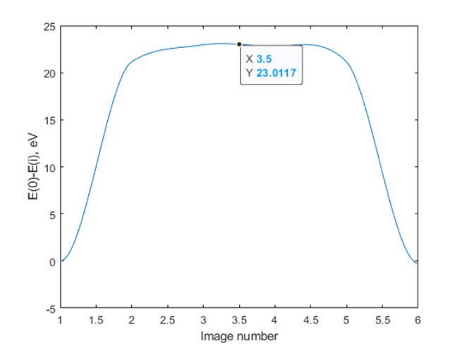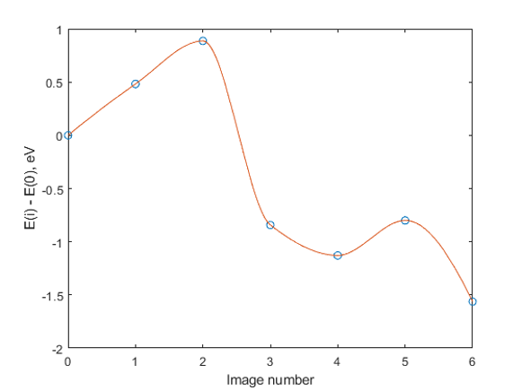

NEB runs

Pre-run checks
For problematic cases like our example, the first step would be to re-relax the end-points with minimal precision settings. Set IOPT=0, IBRION = 3, EDIFFG = -0.01 ev/A, and POTIM = 0.1.

Now that the end-points are re-relaxed, this would help us reach convergence in our NEB runs faster and better.

NEB run
Create a new directory titled 'NEB' and change into it:

$ mkdir NEB
$ cd NEB

Create directories named 00, 01, 02, etc. up to n+2 directories, where n is the number of images of interest. For our example, we shall choose 5 images.

$ for i in {0..6}; do mkdir 0$i; done

Copy the CONTCAR and OUTCAR files from the endpoint runs into the 00/ and 06/ directories.

$ cp ../path/to/initial/run/CONTCAR 00/POSCAR
$ cp ../path/to/initial/run/OUTCAR 00/
$ cp ../path/to/final/run/CONTCAR 06/POSCAR
$ cp ../path/to/final/run/OUTCAR 06/

Interpolate between the endpoints using the nebmake.pl script from the VTST package. Note: you need to have the Perl software installed.

$ nebmake.pl 00/POSCAR 06/POSCAR 5

Set up the KPOINTS file as usual, make sure to generate the POTCAR file. Generate the INCAR file as usual, albeit with a few additions. Set LCLIMB = .TRUE. to turn on the Climbing Image NEB method. Set IOPT = 3 to use the force-based QM optimizer that comes with the VTST version of VASP. Set TIMESTEP = 0.1, IMAGES = 5, IBRION = 3, POTIM = 0.0 and SPRING = -5.

Run VASP as usual in the NEB home directory.

$ mpirun vasp_std

This will run the NEB calculations and relax every image to below the convergence criterion. Note that the endpoints are NOT relaxed! Each directory will have the usual set of VASP output files. The ones of interest to us now are the OUTCAR files.

Post-processing
Once the run is complete and VASP has exited without errors, we can go ahead and plot our NEB band. We can make use of the nebef.pl script from the VTST package to obtain the energies and forces of the images, and further use the energies to plot the NEB band.

$ nebef.pl



We now see two peaks and need to confirm the first peak is the TS using vibrational frequency calculations.

Visualization

We can visualize each of the images using the Atomic Simulation Environment (ASE) Python library. You can make use of this Jupyter Notebook script here:

from ase.visualize import view
from ase.io.pov import write_pov
from ase.io.vasp import read_vasp

for i in range(7):

atoms = read_vasp('./0'+str(i)+'/CONTCAR')
view(atoms,viewer='x3d')
write_pov('atoms_0'+str(i)+'.pov',atoms)

You can then use povray to convert the generated .ini files to high quality .pngs.

$ for i in {0..6}; do povray atoms_0$i.ini; done

You can then stitch together the generated .pngs into a gif:



Vibrational frequency calculations

We need to confirm that our TS is indeed a TS. For this, we make use of its unique property - it has exactly 1 imaginary frequency.

We run a standard vibrational frequency calculation in VASP for the TS image. We set ISIF=2 to lock the change in cell geometry. We set IBRION=5 for vibrational frequency calculations and POTIM = 0.002.

After a regular VASP run,

$ mpirun vasp_std

the OUTCAR file contains the vibrational frequencies. Extract them using the command:

$ grep 'THz' OUTCAR

The output should look like this for image 2 for our example:

1 f = 53.991689 THz 339.239786 2PiTHz 1800.968828 cm-1 223.291757 meV
2 f = 16.683347 THz 104.824561 2PiTHz 556.496538 cm-1 68.996802 meV
3 f = 10.237329 THz 64.323033 2PiTHz 341.480515 cm-1 42.338203 meV
4 f = 9.620520 THz 60.447509 2PiTHz 320.905990 cm-1 39.787286 meV
5 f = 8.223321 THz 51.668651 2PiTHz 274.300462 cm-1 34.008935 meV
6 f = 3.840300 THz 24.129314 2PiTHz 128.098601 cm-1 15.882208 meV
7 f = 3.266313 THz 20.522848 2PiTHz 108.952461 cm-1 13.508388 meV
8 f/i= 0.357185 THz 2.244261 2PiTHz 11.914417 cm-1 1.477200 meV
9 f/i= 16.513405 THz 103.756781 2PiTHz 550.827867 cm-1 68.293976 meV

and for image 5:

1 f = 68.720092 THz 431.781073 2PiTHz 2292.255466 cm-1 284.203559 meV
2 f = 13.824517 THz 86.862000 2PiTHz 461.136224 cm-1 57.173626 meV
3 f = 9.675893 THz 60.795426 2PiTHz 322.753023 cm-1 40.016289 meV
4 f = 7.028329 THz 44.160296 2PiTHz 234.439825 cm-1 29.066844 meV
5 f = 6.511766 THz 40.914632 2PiTHz 217.209124 cm-1 26.930509 meV
6 f = 6.368093 THz 40.011907 2PiTHz 212.416706 cm-1 26.336324 meV
7 f = 6.118939 THz 38.446427 2PiTHz 204.105828 cm-1 25.305907 meV
8 f = 1.760213 THz 11.059746 2PiTHz 58.714395 cm-1 7.279660 meV
9 f = 1.470038 THz 9.236524 2PiTHz 49.035201 cm-1 6.079592 meV

In image 2, there appear to be 2 imaginary frequencies. However since frequency 8 is significantly smaller in magnitude than the others, it can be omitted. Hence image 2 has exactly one imaginary frequency and is the TS.

